***Welcome to Online Learning***

This upcoming week begins our “NEW” way of learning until further notice. I know that this can be overwhelming and a bit scary, but we are going to get through this together! Please reach out to me via Remind or through email at [sstrangio@nfschools.net](mailto:sstrangio@nfschools.net) with any questions.

***STEP BY STEP directions for daily learning***

Go to [www.nfschools.net](http://www.nfschools.net)

In upper right corner – click select a school

Choose Cataract Elementary School

Click Teacher Web Pages

Click Strangio, S – Grade 5

On left side you will see ELA, Math, Social/Science Lessons, Art, and P.E. lessons for the current week.

***To complete MATH lessons:***

Go to the CLEVER website. (<https://clever.com/>)

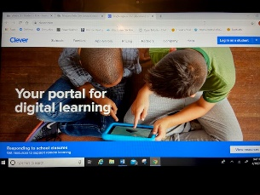

In upper right hand corner, click LOG IN AS STUDENT

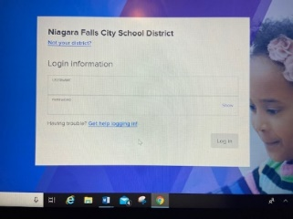

**Username is your student number**

**Password is also your student number**

Scroll down to PowerSchool icon



Login to PowerSchool:

**Username is your computer login username**

**Password is your student number**

Click “Go to PowerSchool”

On the left, click Pearson Courses

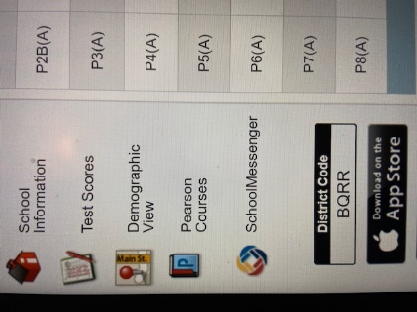

On the right click Pearson Realize

(if you get an error, go back, reload page, and try again).

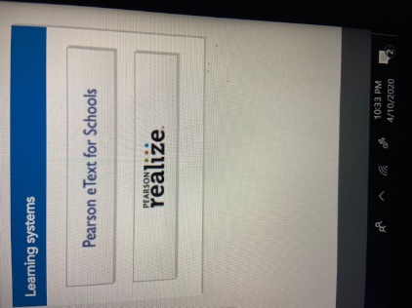

Math assignments will be in the orange box in the center.

They will only show up if there is an assignment for that day.

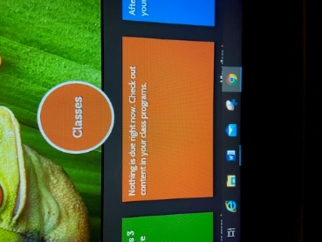

***To complete ELA lessons:***

* Click on the two weekly stories to be read and then answer the questions that follow each story on a separate piece of paper.

***To complete Science/Social lessons:***

Go to the CLEVER website. (<https://clever.com/>)



In upper right hand corner, click LOG IN AS STUDENT



**Username is your student number**

**Password is also your student number**

Click “BrainPop”



Once there, your assignments will show up for you to complete and submit to me.

Please be patient and try your best! I miss you!

Mrs. Strangio